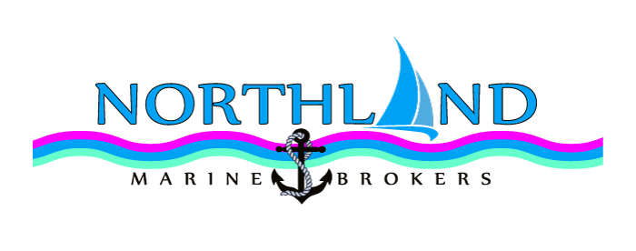
NMB Boat Code | PTS-PP
Price | $65,000.00
Model/Brand | Pelin
Type | Pastime
Length LOA | 29ft
Length LWL | 28ft
Beam | Approx 2.5m
Draft | Approx .9m
Berths total | 4
Designer | Pelin
Builder | Orams Marine
Launched | Approx 1980
Last Refit | Engine 2017 Full Rebuild – Just clicked over 300 hours
Mooring included | No
 | Propulsion:
Num. of engines | 1
Engine type | Ford
Power per engine | 130hp Full Rebuild – Just clicked over 300 hours
Cooling | Fresh water cooled
Fuel type | Diesel
Fuel capacity | 160ltrs
Cruising speed | 7 to 8 knots
Max speed | 9 knots
Range | Weather dependent
Transmission | BorgWarner
Propellor | 3 blade
Bowthruster | No
 | Build:
Hull material | Glass over Ply
Construction
Glassed over
 | Facilities:
Electrics | GPS, Depth Sounder, VHF Radio
Entertainment | Stereo
 | Domestic
Water capacity | 120 Litres approx
Water System | 2x water tanks under double bunk
Accommodation | 1 x double bunk, 1x ¾ bunk , one small bunk over top of double
Head | Yes, new manual pump style
Showers | 1 in cockpit.
Galley | Gas cooker
Fridge | 1, solar power assisted
Freezer | no
 | Communications
Communications | Vhf radio
 | Navigation and Electronics
 | Ground Tackle and anchors
Ground Tackle | Rope and chain, anchor
Anchor winch  or capstan | Capstan
 | Safety Equipment
 | Lifejackets
 | Extras
 | Tender
 | Yes, inflatable dinghy included

